Project Nova – Report
Introduction
Project Nova is a two-player guessing game built with Java and Java Swing. Players takes turns guessing cells on each other’s hidden boards to uncover randomly placed creatures and earn points. The game features scoring, save and load function and a graphical user interface.

Implemented Features
- Two player gameplays
  - The game support exactly two players. Each player has their own Player (name and score) and their own board.
- 5x5 board with hidden creatures
  - Each board is a 5x5 2D grid. The board class use char [ ][ ] for the cell and
Boolean [ ][ ] for track which cells are revealed.
- Random creature placement
  - Creatures are randomly placed on each board at the start of each game.
- Scoring system
  - +5 points for a normal hit AND +10 points for completing a creature.
- Main menu screen
  - Implemented the GUI class using JFrame and CardLayout. The menu includes (Start new game, Load saved game, View help, Exit)
- Game Screen
  - Display current player’s name, shows both players scores, display a clickable grid of buttons representing the opponent’s hidden board and use colours to show revealed cells.
- Save and load game
  - Implemented the FileHandling class using ObjectOutputStream and ObjectInputStream.

Key Design Decisions
- Object Oriented Structure
  - Six classes (Game, Board, Creature, Player, FileHandling, GUI) this keeps the logic clear and makes features easier to implement.
- Pseudocode for placeCreatureRandomly

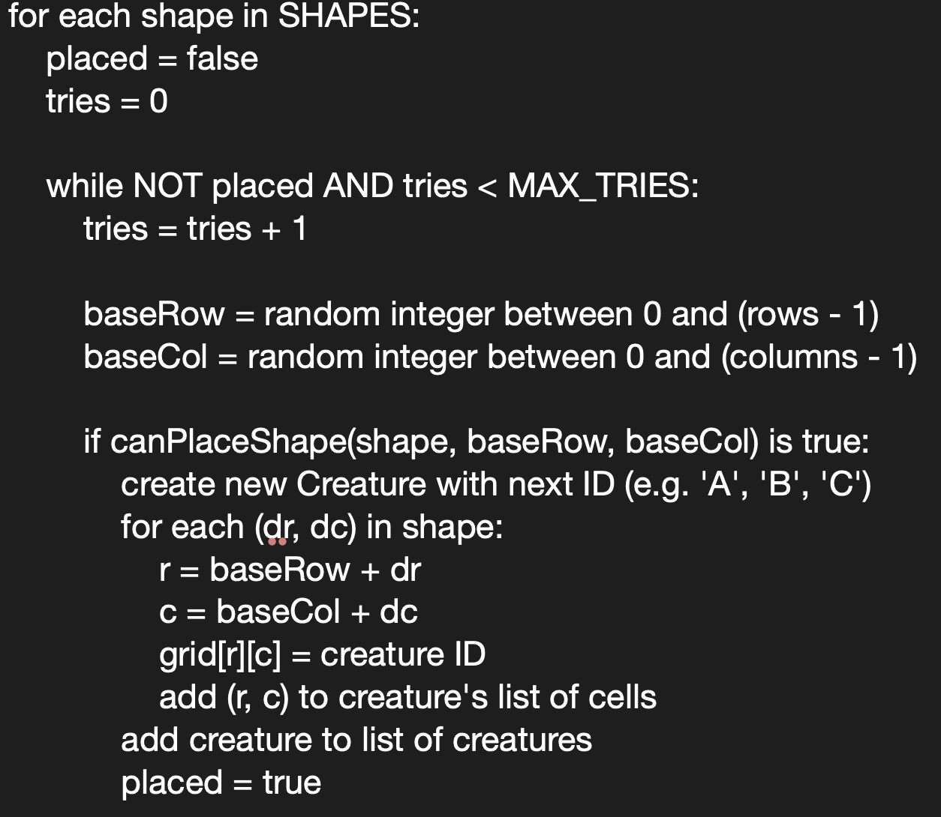

- GUI Design
  - I used CardLayout in the GUI class so that I can easily swap between the Menu screen and Game screen

Self-Evaluation
- Main Challenges
  - Designing how the Game, Board and Creature classes work together.
  - Integrating the GUI with the game logic was tricky. I had to constantly update buttons and colours.
- Strengths and Weakness
  - Strength is that use of six different classes, which makes the code much easier to understand and edit.
  - Weakness is that some input validation could be improved like entering player name or loading a file.
I am proud of the overall structure of the project and how well the classes work together. I am also happy with the GUI it is simple but I think it is effective, make the game easy to follow and interact with.

